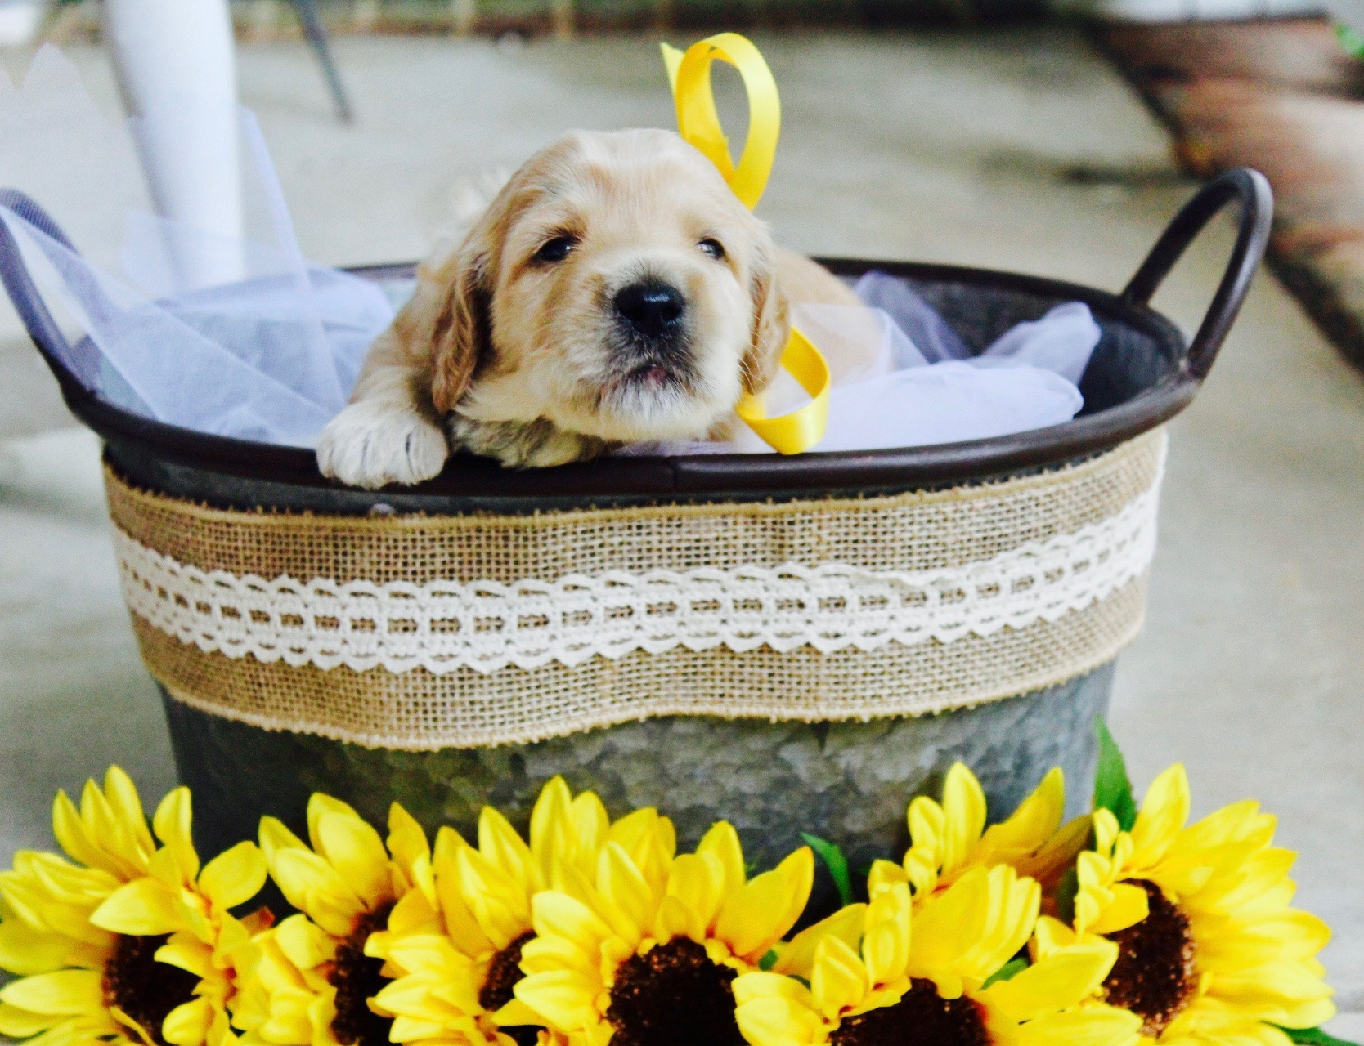
Beechwood Goldendoodles cannot over-emphasize the seriousness of keeping your puppy AWAY from other dogs and public areas—particularly dog parks and parks in general, until your puppy is fully-vaccinated. Parvo and many other canine diseases are DEADLY to new puppies.

Beechwood Goldendoodles Health Guarantee

Our Promise
Our goal at Beechwood Goldendoodles is that each of our puppies have a loving home with a caring family, one who is perfectly pleased with their new furry pal. We also take every precaution we can to ensure your puppy’s health from conception to the time you take them home. In fact, our kennel meets the Goldendoodle Association of North America’s (GANA) highest qualification, Blue Ribbon, which includes multiple genetic and congenital disorders including genetics, orthopedic, heart and eye. Know that we remain available to you, and are delighted to offer support when needed, throughout the life of your puppy. We also value this opportunity to collect information in order to improve our kennel producing the best possible goldendoodles. All Beechwood Goldendoodles puppies come with a short-term as well as a long-term or two-year health guarantee.

Short-Term Health Guarantee

We provide a general health guarantee that we have delivered a healthy puppy to you, one that has had all of his or her required vaccinations, deworming, and any other necessary veterinary attention. We request that you take your puppy to a licensed veterinarian within three business days to be fully examined and for you to personally inspect. Beechwood Goldendoodles will not be responsible for any vet bills. Worms, or internal parasites, are common in puppies. At each puppy check-up, please have a stool sample examined by your vet. Until your puppy has been fully-vaccinated, do not expose him to areas or parks where other dogs frequent, due to risk of parvo and other diseases.

There will be no returns on any puppy unless you have met the above criteria. If your puppy does become seriously ill within this time frame, please take your puppy to your licensed veterinarian. If your veterinarian finds the puppy to have a health issue of such serious nature that the quality of life of the puppy will be shortened or seriously altered, have your vet send all records (to include a full description of the diagnosis) to the Seller or Seller’s veterinarian prior to any return of a puppy for refund or replacement puppy from the next available litter.

Particulars of our short-term health guarantee are detailed in our buyer-seller contract at
https://www.beechwood-goldendoodles.com/contract-for-buying-a-puppy.

Long-Term Health Guarantee
Your new puppy comes with a genetic and life-threatening congenital defect guarantee that covers his or her eyes and hips until 24 months of age. If there is concern during this time that your dog exhibits symptoms of a life-altering congenital defect (such as moderate to severe Hip Dysplasia-HD), the Buyer agrees to pay for and provide all documents from their primary veterinarian and a second opinion from another licensed veterinarian agreed upon by the Seller. In the case of HD, X-rays must be obtained and sent to the Seller’s veterinarian and the Orthopedic Foundation of Animals (OFA- counts as second opinion) for review and grading at the Buyer’s expense. Only moderate to severe HD will be covered. If all the above are met and agreed upon by the Seller’s vet, the Seller will reimburse up to 50% the purchase price of the puppy for treatment. In the rare instance of a puppy dying from a genetic disease, we will replace your puppy with one from our next available litter for free, minus transportation costs. The Seller requires a necropsy report (done at the Buyer’s expense) completed by a qualified and licensed veterinarian that must show that the cause of death was directly related to a genetic condition.

This guarantee only applies to the original purchaser of the pup. It is void if the condition was caused by injuries acquired through training, play, or other activities or, if the puppy has been neglected, malnourished, or allowed to become obese.

Particulars of our health guarantee are detailed in our buyer-seller contract at https://www.beechwood-goldendoodles.com/contract-for-buying-a-puppy.

Best Regards,

Beth and Joe Robles
Deanne and Tim Geurkink
Beechwood Goldendoodles
​
803.477.8307
864.360.4524

