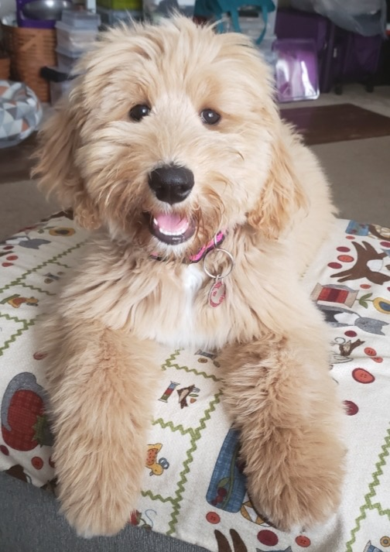
So you’d like to become a part of the Beechwood family as a Guardian?
We don’t believe dogs should live in a kennel. They should have a family. I decided early on that I could love on and give the utmost “pet” attention in the best way to just two adult dogs, Lucy and Max. My business partner felt the same about their dog, Mindi. So how could we provide litters of incredible, sweet, loving puppies with only one or two dogs? Enter the Beechwood Guardianship Program! A Beechwood Guardian is a person (or people) who agree to raise and care for one of our adorable Goldendoodles as a loved family pet for the duration of its breeding career. For a female, this lasts until around the age of four or five and for a male, around age of eight. Even though this dog legally belongs to us, he or she is your pet, and full legal ownership transfers to you after he or she leaves our breeding program.
Beechwood Guardian Rosemary
Why this method? Because it’s . . .
Great for the dog—breeding animals should be no different than any other happy pet—leading a happy, healthy life as a loved family pet (thus eliminating awful puppy farms).
Great for you—together we will have a vested interest in this pick-of-the-litter, partnering together in health and genetics so that you will have the healthiest pup possible AND one you did not have to pay a designer-dog price to acquire.
Great for the puppy buyers—the best puppies come from a family pet environment.
Great for us—we will have the assurance and assistance in raising a parent dog who is well-loved and cared for, so that our energies and resources can be focused on the high level of physical and emotional demands that come with raising litters of puppies.
It’s a true win-win-win-win!

Now the real question: Should you become a Guardian?

Based on your individual circumstances and motivation, and assuming you’ve perused and understood our guardian description and contract on our website at https://www.beechwood-goldendoodles.com/guardian, the following questions will help us, and you, determine if joining our guardianship program is a good fit for both of us.

What are your motivations for wanting to be a part of our Guardianship Program?

___________________________________________

___________________________________________

___________________________________________

If you are considering a female, are you willing to deal with her going into heat? This means dealing with spotting blood, keeping the dog away from other un-desexed dogs and sometimes having to cancel or rearrange social plans because your pet’s cycle is getting in the way. It also means not leaving her unattended during her heat, even in a fenced yard (males can find miraculous ways to get to her!) and to have her on a leash at all times when you are out and about with her during her heat.

Yes
No
Not sure, can we discuss?
Concerns and/or questions:

_________________________________________________

_________________________________________________

Are you willing to work with Beechwood Goldendoodles? You can expect a few extra vet visits, check-ups, and your pet going on ‘honeymoon’. Whilst we will work with you, you need to be willing to be supportive of the process and be accommodating with balancing your family life and your pet’s needs.

Yes
No
Not sure, can we discuss?
Concerns and/or questions:

_________________________________________________

_________________________________________________

Do you like us? Haha! I had to throw that in. For this relationship to work, you need to like and trust us to work well with us. At times, we’ll have a lot to do with each other and we want to make sure we can communicate effectively and get along.

Yes
I think so, but I’d like to know more about you or your program, particularly:

_________________________________________________

_________________________________________________

Can you put the time into training? Your dog needs to be a Lassie. Not! No one says your dog needs to be perfect, but basic obedience is crucial for all breeding dogs. If you want to reduce stress on your pet, it’s helpful to maintain consistency with the rules and expected behaviors between your house and the breeder’s house. You need to be willing to socialize your dog and put the effort into exposing him or her to other people and animals.

Yes
No
Not sure, can we discuss?
Concerns and/or questions:

_________________________________________________

_________________________________________________

Can you give your dog up for weeks on end every year? Ouch. This is the hardest part. But when your dog is ready to whelp a litter, unless we’ve worked out the rare occasion where you will help with the litter in your own home, she will return to us for about seven weeks. That’s a long time to be without your family pet! After the first few weeks, we may allow a visit. It’s emotional, and if you have young kids, it might be a difficult concept to explain. Ultimately though, you do get the joy of knowing your dog is going to have babies that make another family as happy as she makes you. As far as breeding, female dogs in our program are usually absent from the guardian family for 2-4 days, however sometimes are returned the same day. Then she will remain with you at your home until 4-5 days before her due date. An upside to these absences is that it becomes a wonderful time to plan family trips without worrying about doggy care.

Yes
No
Not sure, can we discuss?
Concerns and/or questions:

_________________________________________________

_________________________________________________

When she nears the projected time frame that she may go in heat, will you commit to check her per our instructions every day or every other day to see if she has begun bleeding? Dogs may have a wide range of when they could come in heat. We do not breed on the first heat, which typically happens between nine months and one year of age. After which, they fall into a pattern of heat that will be every six, seven, eight, nine or even ten months. But this pattern may at times vary by a couple weeks or even a month or more. It is crucial for us to know when she starts her heat, especially on her second one. Knowing when she begins her heat helps us to know when to begin progesterone testing, which helps predict ovulation. Not only will we know the best couple of days to breed, but we will know her whelping date, which is 63 days after ovulation.

Yes
No
Not sure, can we discuss?
Concerns and/or questions:

_________________________________________________

_________________________________________________

Are you planning on staying put for the next few years? It goes without saying but if you’re considering a transfer to Dubai or somewhere more than the suggested distance from our program, this will not be a beneficial arrangement for either of us.

Yes
No
Not sure, can we discuss?
Concerns and/or questions:

_________________________________________________

_________________________________________________

If an emergency or an unforeseen circumstance necessitates such a move, are you prepared to work with us, at Beechwood’s discretion, to return the dog to us (not a favored scenario), or work with us from the new locale through adaptions in the program via guidelines set forth in our contract, or pay a sliding scale fee detailed in your contract based on how long you’ve had the dog? It can sometimes take well over a year to secure a guardian dog--from finding a breeder willing to open their bloodlines to us, to making sure a guardian dog has met the genetic and health criteria required for Beechwood to remain at the highest blue ribbon level for the Goldendoodle Association of North America, to even to affording one, as they are double or triple the current market price. Each guardian represents a unique, integral, and irreplaceable part of our program.

Yes
No
Not sure, can we discuss?
Concerns and/or questions:

_________________________________________________

_________________________________________________

Are you willing to let us know when you will be going out of town for trips and making sure we have the contact information of where the dog will be staying, should she come in heat? Making sure we do not miss a heat and that we can plan if there is a chance your dog could go into heat while you are on a trip is paramount. Often we have buyers that are on our lists nearly a year, and we do our best to not miss their opportunity for their special puppy they’ve long awaited.

Yes
No
Not sure, can we discuss?
Concerns and/or questions:

_________________________________________________

_________________________________________________

If you are considering being a guardian to a male, are you willing to bring him to us up to several times a year for his stud service? Transportation to and from our facility will mainly be your responsibility, but of course can be worked out and shared when needed. He will typically stay 2-3 days with us. You will have very adequate notice.

Yes
No
Not sure, can we discuss?
Concerns and/or questions:

_________________________________________________

_________________________________________________

For a female, do you live within two hours of 26147 Raccoon Ford Road, Culpeper, VA (for our Virginia guardianship) or 6 Morning Star Court, Irmo, SC (for our South Carolina guardianship) OR for a male, do you live within 45 minutes of the location of the program in consideration?

Yes, I live _______miles from the ________location
No, I live ______ hours from the ______location
Concerns and/or questions:

_________________________________________________

_________________________________________________

Are you willing to protect the puppy from repeatedly going up and down too many stairs and refrain from having it run miles its first year of life? This is crucial to protect the hips as they develop. Hips are one of the primary tests we do at one year of age, and can be damaged from environmental stress factors such as these.

Yes
No
Not sure about this. Can we discuss?
Concerns and/or questions:

_________________________________________________

_________________________________________________

Does your property have a fenced in yard? (Not required, but strongly recommended)

Yes
No
Planning to install on the date ____________________

Will this dog live in your home, not outside?

Yes
No

Are you prepared to pay for Trupanion health insurance which is about $38/month, OR assume medical bills for illnesses or injuries unrelated to the breeding program? We will handle foreseen and unforeseen medical expenses related to our breeding program, but it is important that we can be confident you are prepared to financially handle pet-related illnesses, medical emergencies, and accidents.

Yes
No
Not sure, can we discuss?
Concerns and/or questions:

_________________________________________________

_________________________________________________

Will you be willing to send an update and pictures once a month for the puppies first year of life? It is wonderful for us to keep up with the puppy and see how he or she is developing and changing in looks.

Yes
I’ll try
Yes, but would like reminders!

Are you willing to keep the dog’s coat and appearance in excellent condition by regular visits to a professional groomer?

Yes
I’d prefer to groom the puppy myself
How often do you plan to take the dog to the groomer?
_________________________________________________

_________________________________________________

Are you willing to regularly brush the puppy to mitigate matts and to prevent the dog from needing to be shaved down? It has happened to the best of us Goldendoodle owners at one time or another, but aiming to prevent those matts is key to keeping a gorgeous coat.

Do you live near a major highway?

Yes
No
If yes, describe in relation to your home:

______________________________________

Has reading these questions caused you to pause and reconsider, or realize you need to know a bit more? If so, which part of our program causes you to do so? Anything we can discuss with you?

__________________________________________

__________________________________________

Will you be willing to pay half the current market price of the puppy, up to $2500, in the unlikely event that the puppy is not a good fit for our program? By a year of age, once we receive all of the results from health testing, we are then able to assess whether or not he or she will enter our breeding program. If for any reason we decide not to breed the Guardian Puppy placed with you (this is a decision solely made by Beechwood Goldendoodles) we will then pay to spay the Guardian puppy at no cost to you.
Yes
No
Not sure, can we discuss?
Concerns and/or questions:

_________________________________________________

_________________________________________________

Thank you so very sincerely for considering the opportunity to love on one of our sweet puppies as your very own. We are so appreciative of our guardians and could not run such a successful program without people like YOU! Please be assured, our questionnaire is in no way geared to be intimidating or prohibitive, but simply to lay out the toughest scenarios and considerations that need to be thoughtfully processed before committing. This is key not only for us in running a successful program, but so that you are prepared to enjoy your pet and guardianship to their fullest!

