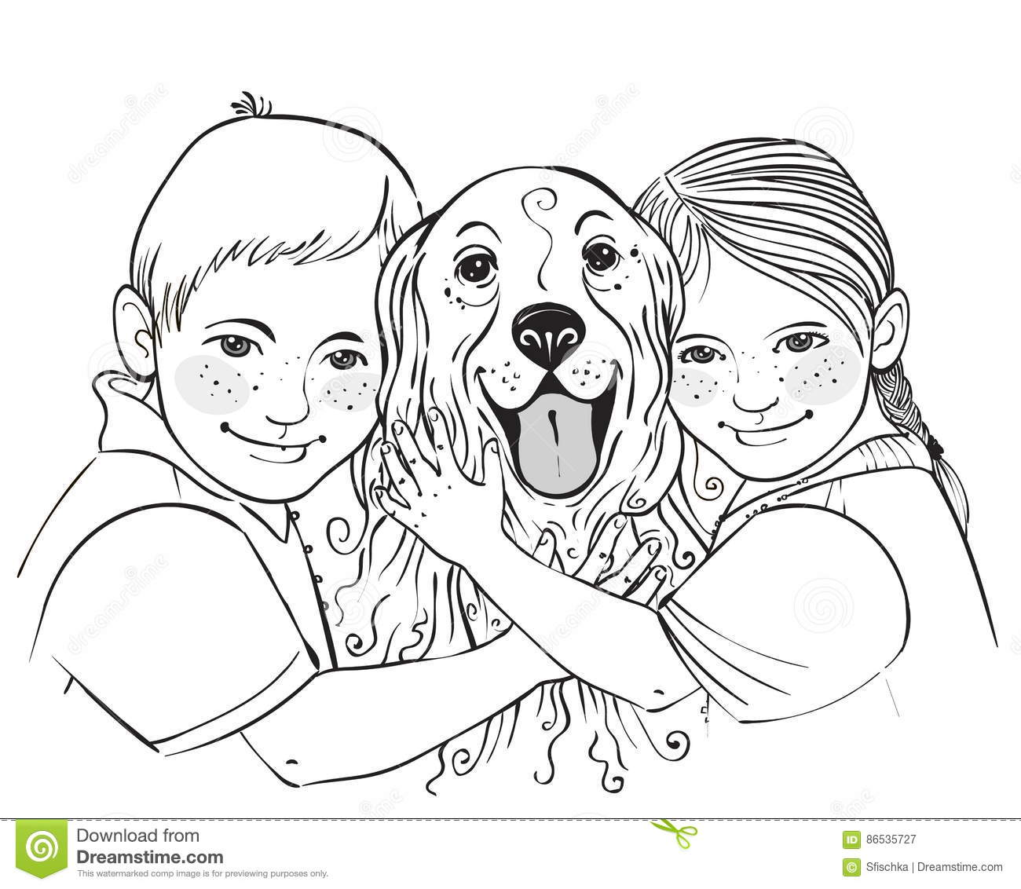 THE KEY TO TRAINING SUCCESS—YOU!

KEY #1: SPEND TIME

During the first two to three weeks your puppy is home, spend as much time with him as possible. Be consistent, patient, praise when appropriate, and no matter how long it takes, be willing to invest the time and energy necessary to make this important training time successful. Whatever amount of effort you invest now in your puppy will be well worth it for the remainder of his life.

KEY #2: USE A CRATE

First, buy a crate. During the first few weeks, keep your puppy in it whenever you’re not playing, holding, or watching him explore his new surroundings. Spend a much time as you can with your pup. When you can’t watch her, crate her, and that will prevent accidents from occurring. As den animals, dogs naturally avoid soiling their bed, so a crate is a key element in housetraining. For you, that’s great on a practical level. They learn to control their urge to eliminate until the proper time and situation. Also, very importantly, a crate is your puppy’s safe and secure refuge.

KEY #3: MAKE A SCHEDULE

Establish a schedule, and don’t deviate. The “when” and “how” you housetrain needs to be consistent. Make sure all family members follow the same guidelines. Find a spot in your yard, and take your puppy there on a lead when it is time for him to eliminate. The odor from previous visits to this spot will encourage him to continue visiting it for elimination. It helps to use the same word when it’s time for your puppy to go. You could use “outside” or “do your stuff,” for example. Consistency is key. Using the same word will build a level of communication between you and your puppy. Be patient. Sometimes they may go more than once. Don’t distract him, but keep him focused on the job at hand. This is a business trip, not social time.

KEY #3: OFFER PRAISE

Praise your puppy for her success when the job is done.

KEY #4: REMEMBER—ALL WORK, NO PLAY

Don’t mix business with pleasure. When your puppy has finished, take her back inside and spend some time with him. Rest assured, there is little chance your puppy will have to eliminate for a while. So, enjoy her and have a good time playing! The more time you spend with your puppy, the better. She is still young, developing, and learning. When you are finished playing with her, take one more trip outside and then put your puppy back in the crate.

KEY #5: FORM HABITS

Dogs are creatures of habit. They like to eat, sleep, and relieve themselves on a regular schedule. Create and stick to a schedule. Watch his behavior so you learn when your puppy naturally defecates—morning, night, 30 minutes after eating, etc.

KEY #6: KNOW TELL-TALE SIGNS OF POOP AND PEE-TIME

As soon as you see your dog pacing, sniffing, turning in circles, or trying to sneak away, take her outside! These are tell-tale signs she needs to relieve herself. If you catch her in the act of having an accident, forcefully tell her, “NO,” pick her up, and take her outside. If you don’t catch her, don’t scold her. Clean up the mess, and scold yourself for not being available.

SAMPLE SCHEDULE
FOR WORKING FAMILY

So . . . you just got your puppy home. You have to go to work tomorrow. Now what? Here’s an example of a schedule for a puppy from eight weeks of age to six months, eating 2-3 meals a day. If someone is home, ideally the puppy would spend one three-hour stretch in the crate and have more interaction outside the crate than you’ll be able to provide having a full-time job and no one at home. But it IS doable!

(This will also give you an idea of the time involved in housetraining a puppy.)

7 AM Take pup out. Don’t wait until you shower or until the coffee is made.
7:15 Kitchen playtime
7:30 Feed and water. Allow 15-20 minutes for eating, then remove dish.
8:00 Take pup outside. Confine to crate when you leave. Place safe chew toys in the crate for entertainment. If you will be remaining home, allow puppy to have supervised playtime and take outside every 45-60 minutes to eliminate.
NOON Take pup out if arriving home on lunch break.
12:15 Kitchen playtime
12:45 Take pup out
1:00 Confine to crate when leaving. If remaining home, this is a good time to have the puppy nap in the crate.
4:00 Take pup out if home
5:00 Take pup out if arriving home from work*
5:15 Kitchen playtime
5:30 Feed and water
5:45 Take pup out
6:00 Supervised playtime for the rest of the evening, taking pup out every 45-60 minutes.
7:45 Take pup out
8:00 Keep puppy up and awake until time for bedtime, taking puppy out every 45-60 minutes.
11:00 Take puppy out. Confine to crate overnight.

* When possible, your puppy should not be crated once you are home for the evening. This is when you spend quality time with her and work on basic obedience.

OTHER TIPS HEALTH, CARE, AND TRAINING TIPS . . .

OH NO, NOT ANOTHER SHOT!

Vaccination protocols are no longer the same. Most of them are no longer recommended annually. Over-vaccination has been linked to cancer and over-stressing the immune system, shortening lives. Click here for more information.

CHOW TIME!

Your eight-week-old puppy has been used to having free access to dry puppy food 24 hours a day. It is now time for our puppy to have regularly scheduled meals. Offer four meals a day. Do this for the first two weeks—breakfast, lunch, dinner, and an evening snack. Your puppy may only nibble at these meals or may not be interested at all in some meals. Make the meal available for 15 minutes. If the bowl is emptied, offer more. Offer water only at meal times until your puppy going to the door to ask out. In two weeks, eliminate the evening snack. In another two weeks, eliminate lunch. Your puppy should be maintained on two meals for the rest of her life. PawTree or Life’s Abundance is the food Beechwood Goldendoodles recommends.

I’M A GOOD BOY, YES? (WAG, WAG!)

Use rewards and treats that are nutritionally balanced. Your puppy can easily fill up on “junk food” during training sessions. PawTree and Life’s Abundance (links are on our website) both have several options for training treats.

It is important to remember that your puppy not only learns when you reward good behavior, but she also learns when you discipline undesirable behavior. If there is a behavior your puppy exhibits that you may think is cute while your puppy is small, you need to think ahead and determine if this behavior will be acceptable from an adult dog. If the answer is “No,” then you need to curb the behavior as a puppy. The most important tool for training a puppy is consistency. Each family member needs to use the same techniques and commands, so as not to confuse the puppy. It is important to remember that a puppy will not associate a reward or a disciplinary action with his or her behavior past three seconds. Waiting longer than this to reward or discipline is very confusing to a puppy.

I’M HOMESICK!

The first week, your puppy will be in transition and have some separation anxiety as he adjusts to his new home. Even though he can sleep through the night, he won’t. Crate training is recommended. The first night is typically the most difficult, but you’ll see improvement each night. The last thing you should do before your bedtime is walk your puppy. Give him ample time to go to the bathroom Then place the puppy in its crate with a towel or blanket and some toys. The crate should be just large enough for the puppy to stand up, turn around, and lie down. Let the puppy cry itself to sleep. He may wake up again and cry, but you should not take the puppy out of the crate until at least three hours have passed. Do not wake a sleeping puppy! Any time after the three-hour limit that the puppy wakes up crying, take him out to eliminate and then put him back in the crate, and let him cry. If you are consistent with this method, your puppy should be sleeping seven to nine hours through the night within a week.

AW, DO I HAVE TO GO TO GET BACK IN MY CRATE?

Regarding crate confinement, your puppy should be placed in the crate during any unsupervised time. The crate is similar to a playpen for a human toddler. When your puppy is eight weeks of age, he is on the same level as a one-year-old toddler. Would you give a toddler free range of house or leave him unsupervised for even a minute?

OOPS! I MADE A POOPY!

If your eight-week-old puppy has an accident that you didn’t catch, scold yourself, not him. He will not associate the scolding with his accident if he was not caught in the act. Be vigilant. Each accident that happens in the house is a step backwards in the training and should be avoided. Don’t allow your puppy access to the floor unless he has eliminated outside within the last 45 minutes. This will help to avoid the accident. If the playtime reaches an hour, the puppy should be taken outside for another chance to go to the bathroom. In the crate, the limit is three hours, but outside the crate, the limit is one hour. Every month, the crate time can be increased by one hour.

GROOMING—“DON’T I LOOK DAPPER?”

Your puppy should be brushed every day if possible. Even though you will not find tangles or mats until the coat grows somewhat, you want your puppy to be used to being brushed. If you wait until the coat is tangled or matted, the process will not be pleasant for you or your puppy, and you want her to learn that grooming is a fun process. As the coat grows longer and thicker, make sure you are brushing from the root out, so you don’t leave mats close to the skin. Brushes you will want to use are a slicker brush to separate the hairs and a metal comb when you are done, as it will find tangles you missed. Every day you should massage the toes gently to desensitize your puppy to make clipping nails easier. Nails should be clipped about once a month. When the adult coat is in (about six months of age), you will want to brush your dog completely at least twice a week, but daily is preferred. At this time, many goldendoodles need their first trim. The dry, unhealthy looking puppy coat can be removed to reveal the healthy adult coat underneath. Multigen goldendoodles typically need to be clipped every six to eight weeks.

GRRRRRR…!!!

Growling needs to be dealt with.

“Resource guarding” is a common problem with puppies and cause of growling. Any puppy that exhibits this behavior needs, at an early age, to be trained away from guarding possessions. Click here for information to assist in this.

Your puppy may also growl from time to time as a way to communicate his dislike of something. This is not a sign of aggression, UNLESS you allow this to go undisciplined over time. Expressing fear when your puppy growls only teaches him that you back down when you hear a growl. You need to actively discourage any and ALL growling directed at you. If your puppy growls at you when you get close to the food bowl, immediately remove the food bowl and feed the puppy out of your hand. If he growls when you brush him, scold him and continue brushing. Do not stop brushing until the puppy accepts this without growling. If he growls as you are trying to take something from him, turn the puppy on its back and promptly take the item from him. Each puppy needs to learn his place in the pecking order of the family. Obviously, they need to be the lowest on the totem pole. If allowed to be boss, growling is a normal thing for a puppy to exhibit when showing his dominance. The behavior is easily curtailed with appropriate discipline. However, many owners or family members become intimidated or fearful instead, adding validity to the dog’s sense of his place in the family. Each family member must establish that they are boss. This includes young children who are timid or fearful of the puppy. Remember that any behavior you allow as a puppy is then extremely difficult to curb later in life.

“IF YOU WANT THE BEST SEAT IN THE HOUSE, YOU’LL HAVE TO MOVE THE DOG”

Speaking of behavior allowed as a puppy that’s hard to curtail later . . .
Let’s talk furniture. It’s simple. If you do not wish for your grown dog to sit on the furniture, do not sit on the sofa holding your puppy. If you do not want your grown dog to grab your pant leg, etc, do not play tug-of-war or other aggressive games with him.

LET’S GO FOR A WALK

The following are videos by Army Maquire on teaching your puppy to walk on a leash:
http://youtu.be/pxpAawMZ2vo
https://www.youtube.com/watch?v=s5g7u0p5yj8&feature=youtu.be
https://www.youtube.com/watch?v=A-0uZNURGO0
https://www.youtube.com/watch?v=5gvO3DEnVRM

OUCH! HE BIT ME!

Click here This will change your whole perspective on dog bites. Watch this! How to avoid children being bitten by the family dog.

As far as playful puppy-nipping and biting, she is teething and has an insatiable desire to chew. You cannot stop this behavior, but you can certainly direct your puppy to chew upon acceptable items until this phase passes (at about one year of age). The only way puppies know how to play is the typical wrestling, biting, chasing, tackling, pulling, and nipping they do with littermates. In the absence of littermates, you and your family suddenly become the litter mates. Every single time your puppy puts her mouth or teeth on your clothes or hands, you immediately need to remove the teeth from it, firmly close the puppy’s mouth with your hand, and firmly, deeply, and loudly say, “NO!” Your puppy will undoubtedly soon nip or bite at you again. Repeat this same disciplinary action a total of three times in a row. After the third disciplinary action, distract your puppy by giving her something she can chew on. Every now and then, a particularly feisty puppy will become more excited by this disciplinary action and need a more distinct disciplinary measure. This next action needs to be initiated quickly. When the first three disciplinary actions don’t seem to have an effect, you can use another technique that may be more successful. Immediately upon your puppy putting her mouth on you, put your thumb on her tongue and your other fingers underneath her jaw and press down on the tongue. This will be uncomfortable for your puppy. When behavior meets with uncomfortable consequences, the behavior will stop. Another option is to mix 30% white vinegar and 70 % water in a small spray bottle. Spray this in your puppy’s face each time he bites at you. With all this being said, the absolute best remedy is for you to arrange daily play dates with other puppies or young dogs. Allowing your puppy to expend energy this way will help her to be much calmer the rest of the day. The bottom line is that your puppy needs to have active playtime each day. It is your job to find or create activities that are fun for your puppy and that tire her out.

GRANDMA GOT RUN OVER BY THE…PUPPY!

Your puppy will jump on Grandma, you, or anyone else to get attention. This may seem cute and innocent while your puppy is small, but Grandma or your guests may not appreciate being knocked over by your full-grown untrained dog. You will need to push your puppy down and say, “OFF,” firmly each time he jumps on a person. Make sure you do not reward the puppy for the act of getting down, as this will enforce the behavior of jumping up so he can yet again get rewarded for getting down.

THE NO-NO FOODS…POISON!
Refer to the “Can Dogs Eat Human Food?” link under Resources for a comprehensive list of human foods that dogs can or should not eat, but it’s worth devoting a whole section to foods that are poisonous to dogs.

- CHOCOLATE (CONTAINS THEOBROMINE)
- ONIONS AND GARLIC
- PEAR PIPS, KERNALS OF PLUMS, PEACHES, AND APRICOTS, APPLE CORE PIPS (CONTAINS CYANOGENIC GLYCOSIDES RESULTING IN CYANIDE POISONING)
- POTATO PEELINGS AND GREEN-LOOKING POTATOES
- RHUBARB LEAVES
- MOLDY/SPOILED FOODS
- MACADAMIA NUTS/WALNUTS
- ALCOHOL
- YEAST DOUGH
- COFFEE GROUNDS, COFFEE BEANS, AND TEA (CAFFEINE)
- HOPS (USED IN HOME BREWING)
- TOMATO LEAVES AND STEMS (GREEN PARTS)
- BROCCOLI (IN LARGE AMOUNTS)
- RAISINS AND GRAPES (DAMAGES THE KIDNEYS)
- CIGARETES, TOBACCO, CIGARS
- NUTMEG
- RAW POTATOES
- TURKEY SKIN
- VOLTARIN (IN ARTHRITIS MEDICATION) VERY FATAL
- BABY FOOD THAT MAY CONTAIN ONION POWDER
- CITRUS OIL
- FAT TRIMMINGS (CAN CAUSE PANCREATITIS)
- HUMAN VITAMINS CONTANING IRON (CAN DAMAGE LINING OF THE DIGESTIVE SYSTEM)
- LARGE AMOUNTS OF LIVER
- MUSHROOMS
- RAW FISH

ANIMAL POISON HOTLINE 1-888-2328870

While we’re on the “poison” topic, here are a few common household items you might innocently have lying around that could poison your dog:

- Household and garden chemicals
- Batteries
- Rat poison
- Antifreeze
- Glow sticks
- Some paints
- Children’s modeling compounds

